London & KSS Employers Portal User Guide

Table of Contents
Introduction 2
Accessing the Site for the first time 2
When your account has already been associated with a Microsoft Account 2
When your account has not yet been associated with a Microsoft Account 3
Signing in with your account after it has been created 5
Creating/Maintaining user accounts for your trust 6
The Homepage View 6
Accessing and downloading reports 7
The Trust Rotation Grid (TRoG) 8
- The Contents View 8
- The 12 week Rotation View 9
- Data Changes………………………….. 10
- The Current View……………………….. 12
- Contact Details……………………….. 12
Placeholders on TROG 13
The Rotation Schedule 16
The Trust Establishment Report 16
Contacts for queries 17
Version Control 18
Appendix I – Data Flow and Components 18
Appendix II – TROG Report Fields 19

- Introduction

The HEE Employers Portal is a Sharepoint portal designed for HEE to securely share Rotation Grids, Establishment Reports and other relevant reporting with Trusts and Lead Employers. Set up with Document Libraries and clearly defined User Groups it allows Trusts to access HEE Reports, which are split into secure folders for each trust to access.

The delivery of this information through a single portal allows streamlined delivery, improved security, relevance and consistency of data shared between HEE and Trusts. The portal represents a single resource where data is refreshed and updated on a daily basis.

- Accessing the site for the first time

You will have received an email similar to the screenshot below, asking you to go to the Employers Portal SharePoint page.

Copy the link and paste it into a new browser in a private/incognito window
This is to ensure you are not signed in on any other Microsoft accounts (e.g. personal accounts) which do not have access to the portal
The process will differ slightly depending on whether your email address is already associated with a Microsoft Account or not.

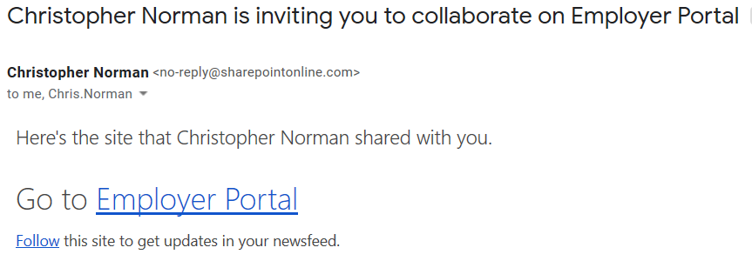

- Scenario A - Sign in process where your email has already been linked with Microsoft

Please sign using the email address your invite was sent to:

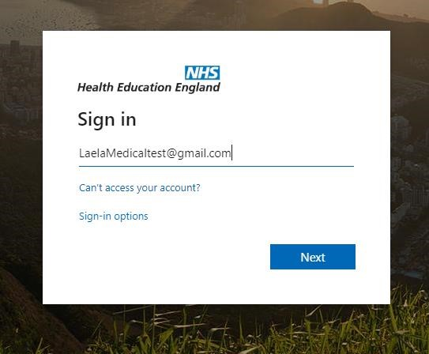

NB: In order to access the site with the correct email address please ensure you are not logged in to any other Microsoft account in your browser. You can do with by using a private/incognito window in your browser

- Scenario B - Sign in process where your email has NOT already been linked with Microsoft and requires an account created/linked

Upon pasting your link into a private/incognito window you will see the following message. Click on ‘Create a Microsoft account’.

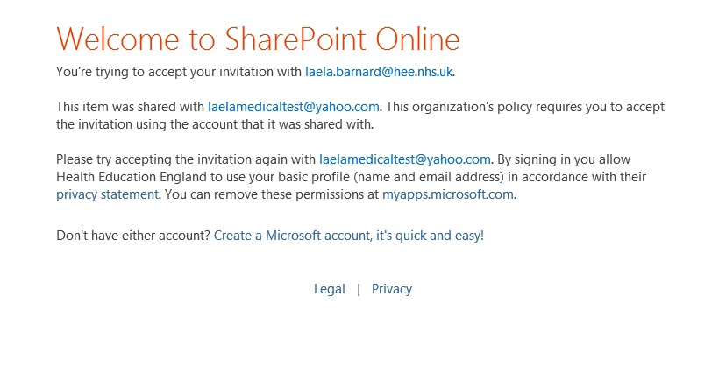

Enter your email address (this MUST be the same email address your Employers Portal invite was sent to) and a password and follow the prompts.
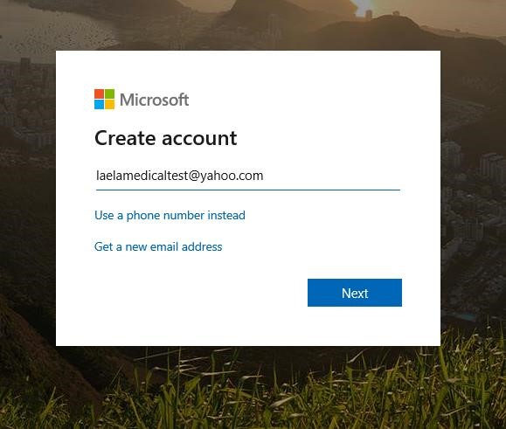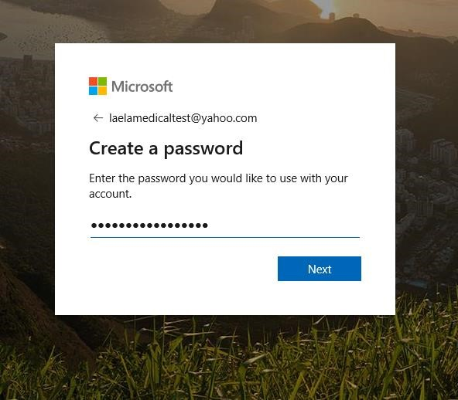
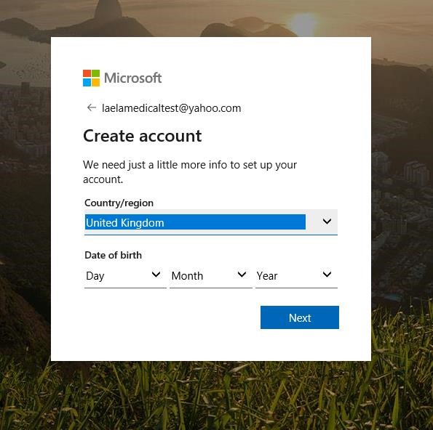

You will need to verify your email address

Log back into your email to retrieve the code
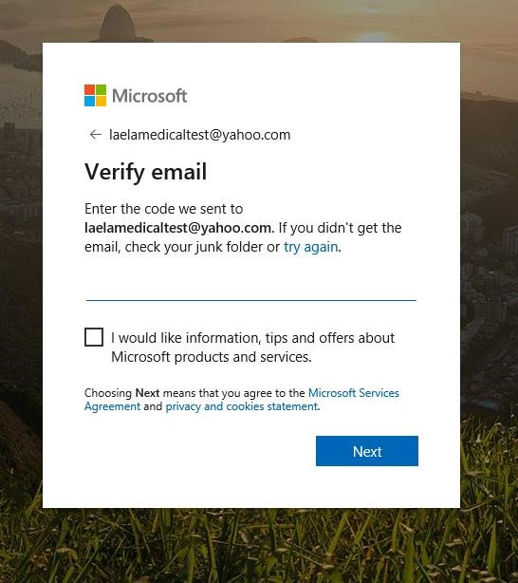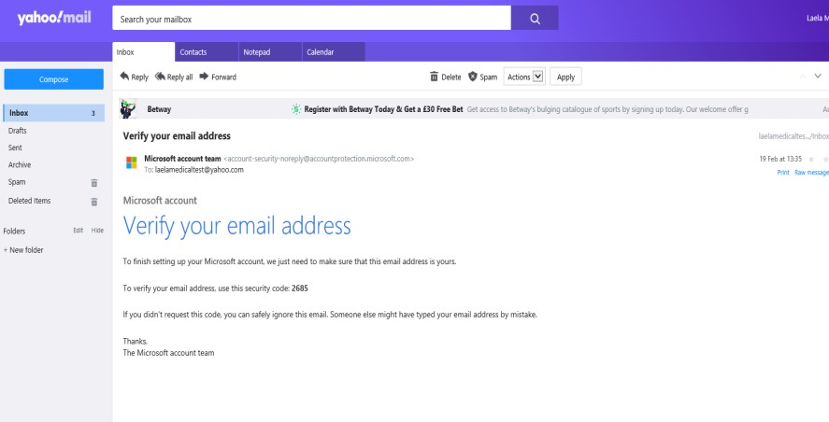

Verify your email address using the code provided, and enter the captcha
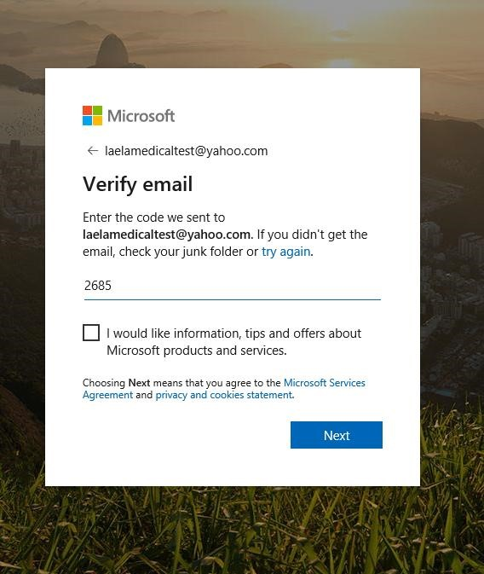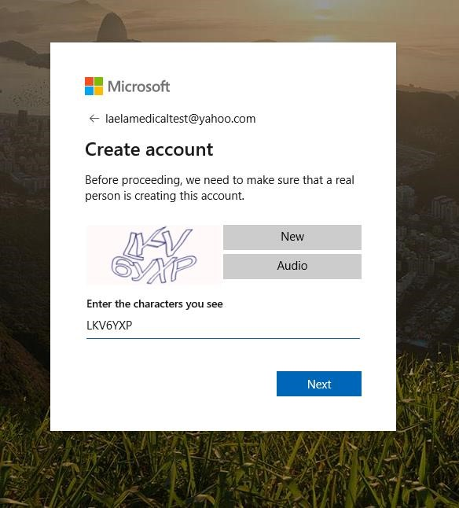
Your email account is now linked.
Now sign out, and log in again using the guidance in 2a) Scenario A - Sign in process where your email has already been linked with Microsoft.

- Signing in with your account after it has been created

It is still recommended to sign in to the Employers Portal in a private/incognito window (or ensure that you are logged out of all other Microsoft accounts within your browser) to ensure that you are logging in with the email address you are registered to the portal with. Your credentials will be the email address you are registered with and the password you use to access that account.

- Creating/Maintaining User Accounts for your Trust

Users require an account to be able to access the portal. Trusts will be responsible for requesting from HEE London and KSS the set-up of new accounts and/or the disabling of old accounts, as required.
This responsibility is very important in ensuring your trust’s usage of the portal meets Information Governance (IG) requirements. Leavers from your organisation will still be able to access this web portal and the personal data being shared, unless you contact London and KSS service desk team and request that their account be removed.

- Recommended account holders
It is recommended that anyone who uses trainee placement data within Medical Education and Medical Staffing teams in trusts have their own account. Only colleagues in these teams are currently able to have access to the Rotations Grid area of the Trust Portal.
- he Trust Portal Account Management form (found on the portal landing page) must be used when requesting account creations or removals. Forms must be sent directly to the HEE London and KSS Service Desk team: servicedesk@hee.nhs.uk

- The Homepage view

The landing page includes an information section, with links to contact relevant HET employees in the Healthcare Education Team and IT. The User Guide and Info section includes a User Guide, the Rotation Publication Schedule and key dates, as well as a link to the reports section, which is updated daily.
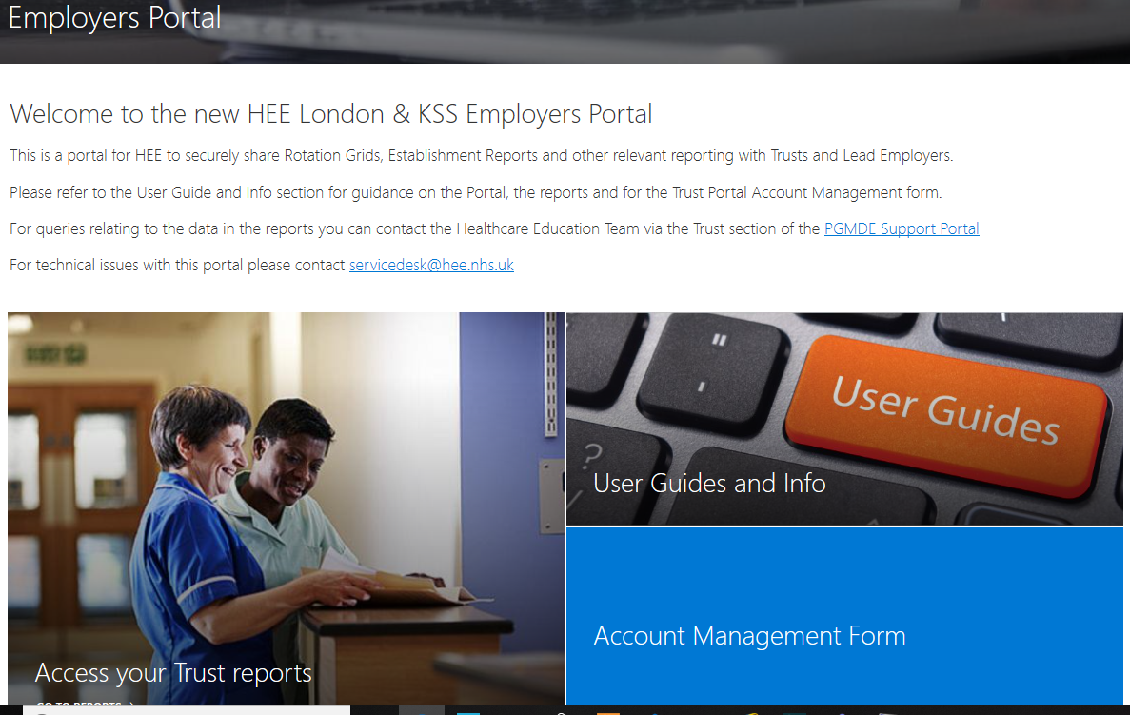

- Accessing and downloading reports

The link below you to the Trust Specific pages. You will see the Trust(s) you have been given access to when you set up your account. You will require Microsoft Excel and Adobe Reader to open these files, once downloaded.

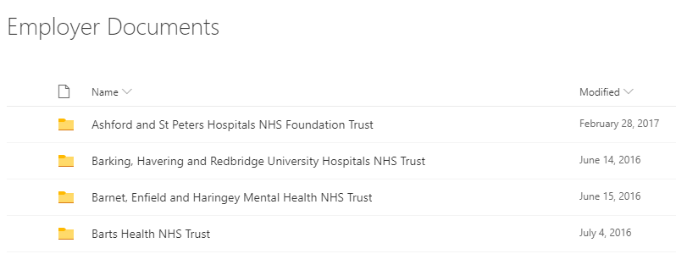

Click on the ellipses next to each file and Download
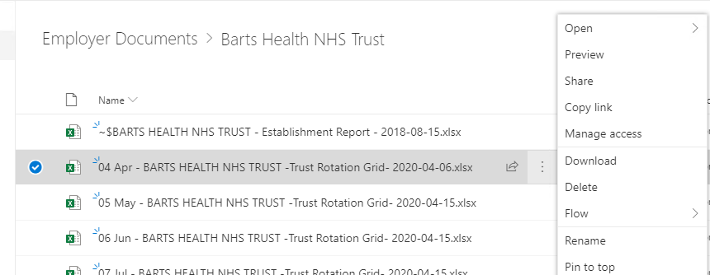

- The Trust Rotation Grid (TROG)

TRoGs contain trainee placement data for trainees due to commence a placement in your Trust. These are published 12 weeks in advance of rotation start dates in line with existing data sharing agreements. You will have access to TRoGs with current data on them i.e. data relating to people due to start in your Trust. TRoGs will be archived once a rotation start date has passed as these are not the method by which HET communicate data relating to trainees already in post. For data on current trainees, please use the Establishment Report. You may wish to download and save these locally before they are archived.
The TROGS contain 5 tabs:
- Contents Page
- 12 wk Rotation Grid
- Data Changes
- Current View
- Contact Details

Contents Page

This page gives you an overview of the data published in the TRoG. Table below explains the fields on display.
Column | Field Name | Description
A | Specialty | Displays the name of the specialty of the programme for which trainee placements appear in the TRoG
B | Programme | Displays the London and KSS name of the programme which will appear in the TRoG
C | Rotation | Displays the rotation name of the programme which will appear in TRoG
D | Expected  Publication Date | Displays the date the data should be published on the sheet. This date is always exactly 12 weeks before the rotation start date
E | Status | Either:  - ‘Published’ i.e. data appears on the sheet for this programme  - ‘Not Published’ i.e. data doesn’t yet appear on the sheet for this programme due to a delay in publication
F | Actual Publication  Date | Displays the date that data was first available on the sheet
G | Date of Latest  Change | Displays the date of the most recent publication of data changes
H | Programme  Completeness (%) | Displays how complete the programme data set is on the TRoG i.e. the percentage of posts that have an allocated trainee or placeholder

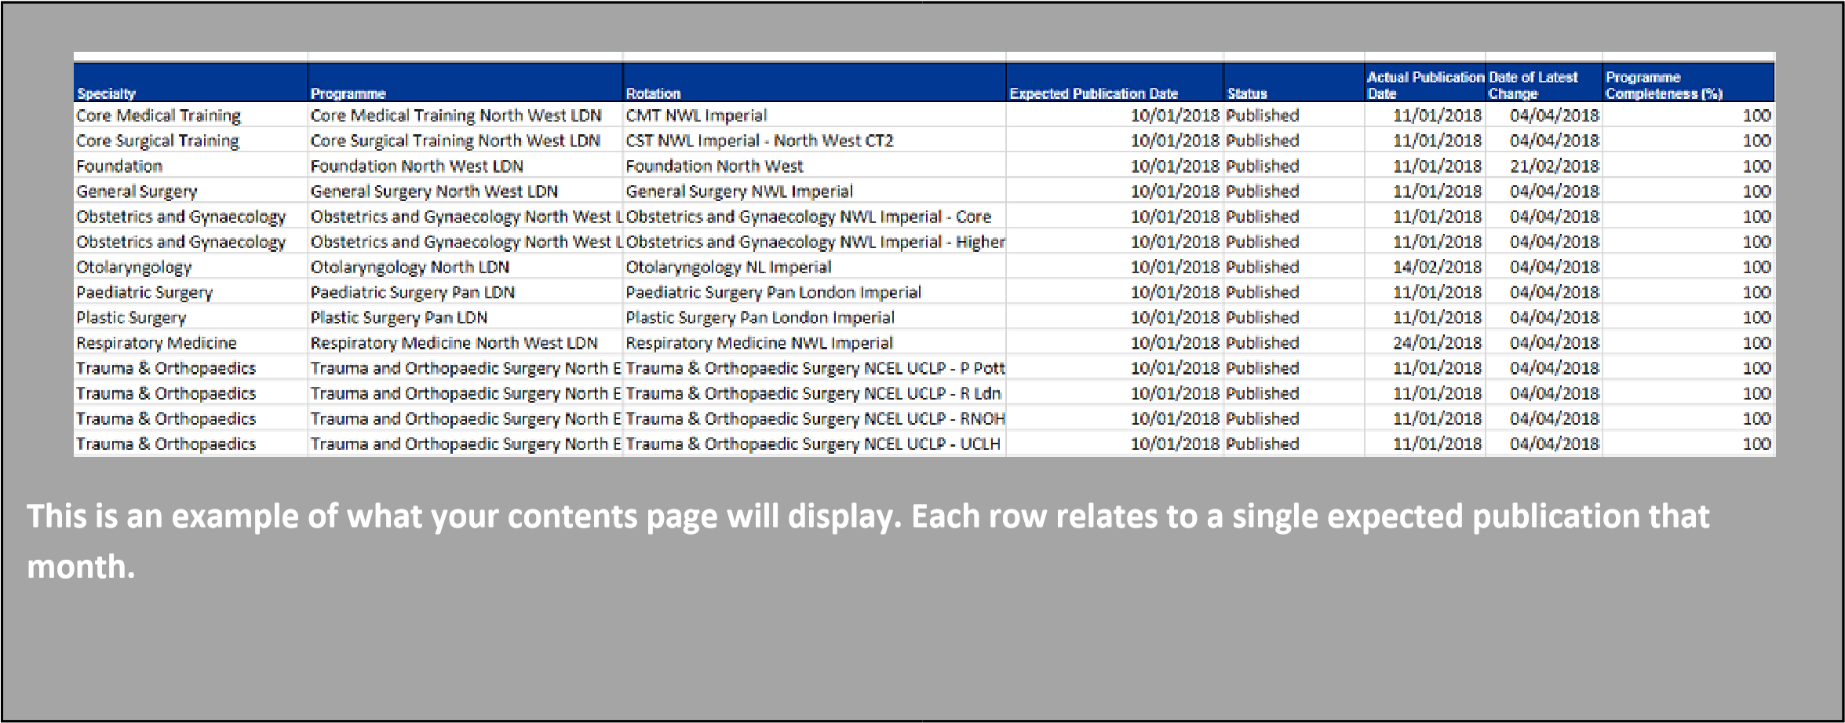
We can see that Core Surgical Training North East UCLP programme was published on the expected date (06/01/17), has since been updated (most recently on 16/02/17) and is 100% complete.

ii. 12 wk Rotation Grid
This page contains data on trainee placements arranged into three main sections:

- Post
- Current trainee
- Future trainee

Data on this tab will be published automatically from the data held in the TIS database exactly 12 weeks before the rotation date.
Fields on this grid were previously agreed between HEE and London trusts and are replicated in the version published on the portal. A full list of fields and descriptions can be found in Appendix II.

Colour coding
There is just one colour coding system on the 12 wk Rotation Grid sheet.
Colour | Description
Grey | This indicates that you should not expect to receive data in these fields as no future placement will appear.  This will be used in scenarios where additional rows appear because of duplicated ‘current trainee’ rows, e.g. instances when the post is currently occupied by two trainees (job shares or maternity leave cover) but only one trainee will hold the post in the future. This will also be used when the post listed will not be used in the upcoming rotation.

iii. Data changes
This page will show you where data for posts and/or future placements has changed since it was first published. Please note that this page will not show data changes for current placements.
This tab comes pre‐filtered to only show you the most current data. Please read Additional columns section below for more information.

Key features
- Based on the same data and columns in 12 wk Rotation Grid sheet
- Additional fields and features to show data changes
- Updated every Wednesday for all programmes on that sheet
- Updated automatically to reflect data changes
- Accrues data change history so you can quickly compare new and previous data on the same sheet
- Data changes for the same post will be grouped together using alternating grey and white colour coding

Additional columns on the sheet
As well as all columns contained on the 12 wk Rotation Grid page, the data change sheet contains five additional columns. This additional information will help you manage your data changes.
Column | Field | Description
AQ | Record Type | - ‘ORIGINAL’ ‐ indicates that this row of data appeared on the 12 wk Rotation Grid page (to be used as a comparison row of data only)  - ‘INSERT’ ‐ indicates a brand new row of data that hasn’t previously appeared on any page  - ‘UPDATE’ ‐ indicates that this row contains a data change when compared to the row directly above it on the unfiltered sheet  - ‘DELETE’ ‐ indicates that this row contains a placement that has now been deleted (shown in red)  You will mainly receive ‘UPDATE’ rows. You should filter this column to compare these to your ‘ORIGINAL’ row and see where the change has occurred
AR | Timestamp | Indicates when the data change was published on the portal  The data change tab is always filtered to only show most recent timestamp but you can see complete or predefined history by adjusting filters
AS | Rotation  Date | Displays the date on which the placement’s rotation will start
AT | Rotation  Month | Displays the month (as a number e.g. January = 1) in which the placement’s rotation will start
AU | Is Current  Record | - ‘1’ shows the current row of data or  - ‘0’ shows previous rows of data i.e. data change history  The data change tab is always filtered to only ‘1’ in this column i.e. the most recent row of data. You can see complete or predefined history by adjusting filters.
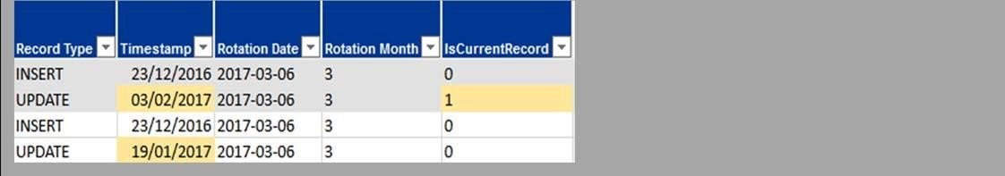

i. Colour coding
The data change tab has colour coding to help you use the data provided. The table below explains what the colours mean.
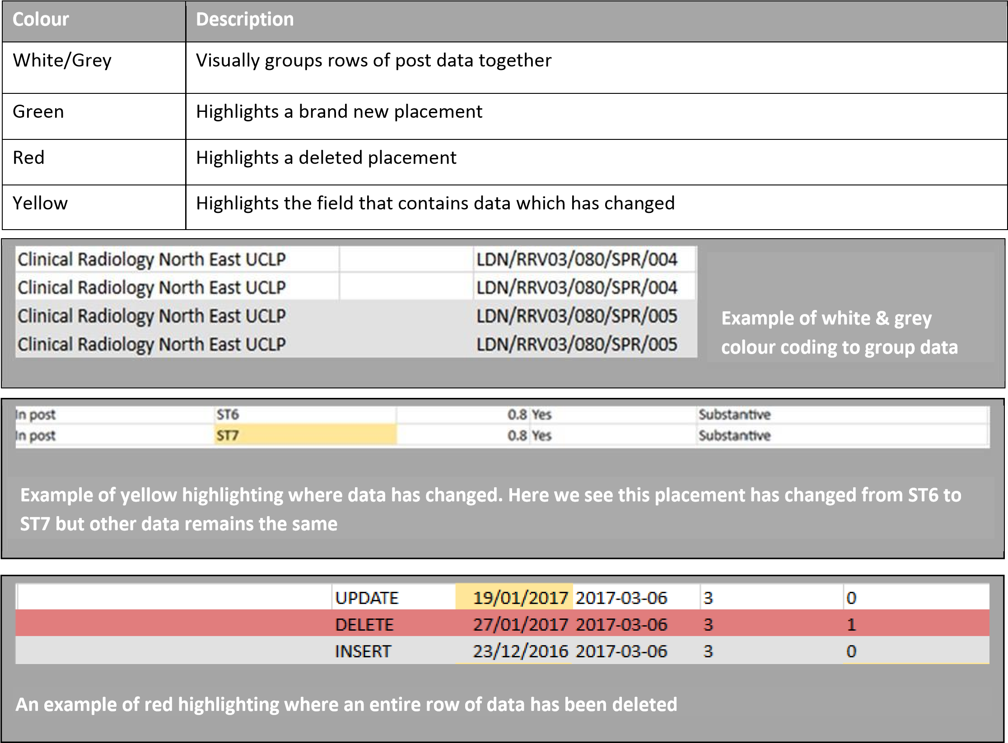

iv. Current View
The Current View tab will provide you with a snapshot report, correct on the day the report is updated. This is where you can check the current view of the report, taking into account changes that have been made since its initial publication at 12-weeks prior to rotation, without any tracking information. This tab also contains a column showing you the London and KSS trust a future trainee was placed in prior to their arrival at your trust. This is the ‘Sending Trust’ column – column AJ.

v. Contact Details
The Contact Details tab will provide you with the contact details of the trainees who are due to join your trust.
A full list of fields and descriptions can be found in Appendix III.

vi. File name

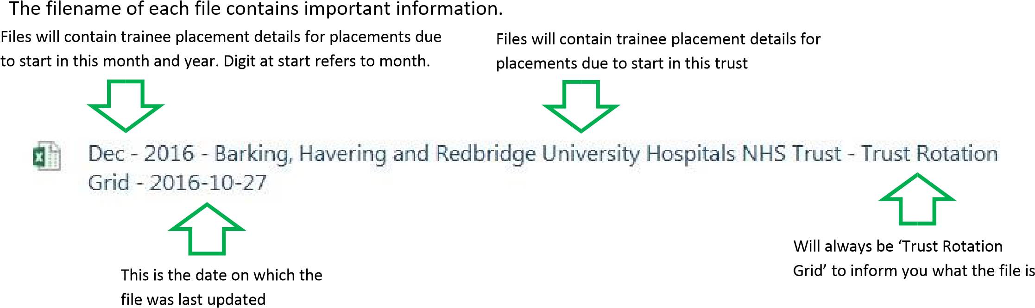

- Placeholders on TRoG
HEE London and KSS use placeholders to standardise the way vacant post information is sent to Trust colleagues.
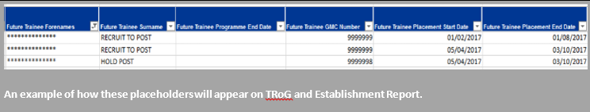

i. Placeholder types on TRoG
Hold categories are used to inform Trusts that HEE London and KSS require longer until they can advise whether the post will be filled and the reason why, e.g., awaiting exam results. The Trust will, in a later TRoG (within the data changes sheet), be informed of the outcome for the post.
Recruitment categories are used to inform Trusts where following the rotation planning process a vacancy has been left at their Trust and provides the reason why.

Where a Recruit placeholder is displayed against a post HEE London and KSS are confirming that the Trust can commence a local recruitment process.

Working with placeholder types on TRoG
The following table lists all of the placeholders that will be used to communicate hold and recruit activity via TRoG.
Where any one of the below Hold placeholders is recorded in TRoG, Trusts should await a subsequent data change sheet to identify if the post is later filled with a trainee, or they have authorisation to recruit locally.
Category | Placeholder name in TRoG | Explanation
Education | HOLD ‐ EDUCATION | Where educational reasons might require specific training locations – used for example when ARCP outcome(s) are awaited
Quality | HOLD ‐ QUALITY | Where quality concerns may result in a post being removed or suspended – used for example when the outcome of a quality visit is not yet known
Personal Health | HOLD ‐ PERS HEALTH | Where trainee personal/health needs require further time to agree a placement – used for example when awaiting a OH report
IDT | HOLD ‐ IDT | Where a post has been ring‐fenced for a trainee who may potentially be placed due to a transfer via the national Inter‐Deanery Transfer process
LTFT | HOLD ‐ LTFT | Where potential reduced sessions, or slot‐share approvals may later result in a placement
Foundation Reserve | HOLD ‐ FND RESERVE | Where a post is ring‐fenced for potential reserve list applicant(s)
Specialty Exam | HOLD ‐ SPEC EXAM | Where a post is ring‐fenced for an applicant, pending a successful exam result
Late Recruitment | HOLD ‐ RECRUIT DELAY | Where the outcome of a recruitment round is not yet known, due to it taking place late, in relation to a rotation date, or where late recycling of offers is still taking place
Internal delay | HOLD ‐ INTERNAL | Where the TPD and/or HET require more time to work through placement queries and update TIS
PG Dean | HOLD ‐ PGD | Where the Postgraduate Dean has agreed to consider a late trainee movement, e.g. OOP or trainee swap.  These will be considered in exceptional cases only.

Where any of the below Recruit placeholders is recorded in TRoG, the Trust can commence local recruitment to fill the vacancy.
Category | Placeholder name in TRoG | Explanation
Education | RECRUIT ‐ EDUCATION | Where trainee educational requirements, e.g. as determined at ARCP, cannot be met by a post
Personal Health | RECRUIT – PERS HEALTH | Where trainee personal/ health reasons cannot be met by a post
IDT | RECRUIT ‐ IDT | Where a post ring‐fenced for an incoming IDT does not yield a trainee
LTFT | RECRUIT ‐ LTFT | Where LTFT approval activity (e.g. slot‐shares being agreed) result in a programme vacancy
Statutory | RECRUIT ‐ STATUTORY | Where a post planned to be filled is left vacant due to a trainee providing short notice of their intention to go on statutory leave
Foundation Reserve | RECRUIT – FND RESERVE | Where a post held for a potential trainee, does not yield a trainee from the Foundation reserve list
Specialty Exam | RECRUIT – SPEC EXAM | Where a trainee recruited through specialty  recruitment subsequently fails their exam, resulting in a vacancy
PG Dean | RECRUIT ‐ PGD | Where the Postgraduate Dean approves a late trainee movement, e.g. OOP or location swap, leaving a vacancy. These will be exceptional cases.
Resignation | RECRUIT ‐ RESIGNATION | Where a new recruit or trainee resigns before taking up their post, leaving a vacancy
Programme Vacancy | RECRUIT ‐ VACANCY | Where there are simply vacancies within the programme, due to regular programme occurrences, e.g. vacancies left following recruitment, programme balance etc.

ii. Placeholders dates on TRoG
Table below explains the placeholder date information you are receiving for all placeholder types.
Column | Field | Description
Z | Future Trainee Surname | Will always be one of the placeholder names. See full list in table below
AC | Future Trainee Placement Start Date | Indicates the date on which your placeholder starts  - If it’s a RECRUIT placeholder, then this indicates is the date your locally recruited placement should start  - If it’s a HOLD placeholder then this indicates the date from which the allocation of your post is on hold
AD | Future Trainee Placement End Date | Indicates the date on which your placeholder ends  - If it’s a RECRUIT placeholder, then this Indicates the date on which your locally recruited placement should end  - If it’s a HOLD placeholder, then this indicates either: o  The end date of the rotation (please note this may change if a trainee is placed into the post after the  12 week notification) OR o The date before a confirmed placement will start

iii. Data changes
Data changes for these placeholder placements will be published at the same time as data changes to all other placement data on that TRoG.
- The Rotation Schedule
The Rotation Schedule publicises the key dates and milestones for every London and KSS programme, including the dates on which data will be published and the dates on which rotations are due to start and finish.
- The Establishment Report

The Establishment Report shows you a list of all the posts in your trust and who the current trainee is on the day of publication. This follows the same automated data flow as with TRoG so you will receive exactly the same data as appears in the HEE London and KSS database.
In order to create consistency, and for ease of use, the Establishment Report will include the same relevant fields in the same format as TRoG. See Appendix II for a full list and descriptions of fields contained in the Establishment Report.
The Establishment Report will be updated every Wednesday. Changes will not be highlighted.
If you wish to query any data on this report, or update London and KSS with trainee information that has not yet been fed back to the team (e.g. trainee is on sick leave), then please contact our Healthcare Education Team (HET) through the Trust-Rotations functionality on our online PGDME Support Portal: https://lasepgmdesupport.hee.nhs.uk/support/home#6

See the Support section immediately below for further details on how to contact our HET team.

- Contact for queries
If your query is relating to the technical functionality of the portal such as;

-Reports haven’t updated
-Issue with a log-in
-The portal is down
- Any other technical issue

Please contact our IT team at servicedesk@hee.nhs.uk

If however, your query relates to the data within the reports such as;

- Specific trainee details
- Trainee missing from the report
- Post missing from the report
- Any other data related issue

Please contact the specialty support team via PSP - https://lasepgmdesupport.hee.nhs.uk/

The PGMDE Support Portal also has an extensive FAQ section.
The portal is also the means through which you are able to provide us with any feedback you might have about the data or to highlight to us where you believe your records are more up‐to‐date than the data published to you on the portal. This feedback loop will HET improve data consistency and accuracy.
The above links are also available on the Homepage of the Employer Portal.

- Version Control

Version | Date | Author | Comments
1 | April 2020 | Maria Kist/Chris Norman | Produced for new portal

- Appendix I – Data Flow and Components

i. Data Flow
Data will automatically be extracted from the TIS database and published to the Trust Portal. Developments aim to automate all the manual parts of our rotation process which are repeatable and rule based. These manual procedures can be slow, wasteful, and error‐prone.
The diagram below shows the flow of data from HEE source to the trust user.
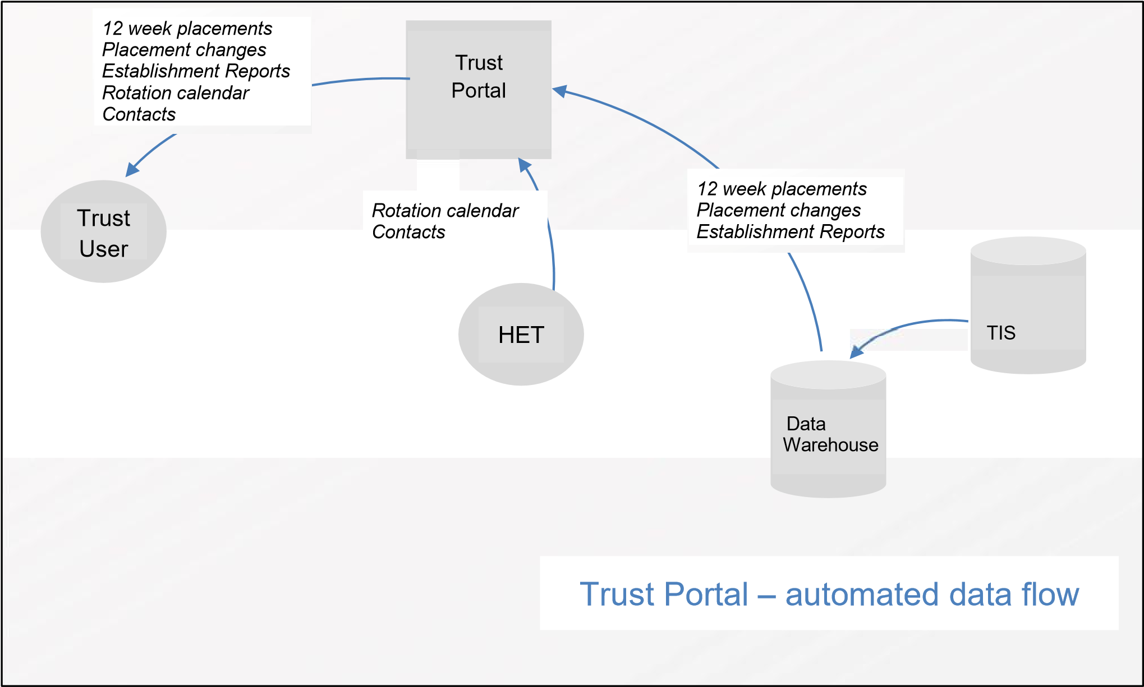

ii. Components
The Trust Portal is just one component of this automated data delivery process. There’s a lot working behind the scenes at HEE London and KSS to make sure trust colleagues receive correct data when they expect to receive it.
The components are:
- TIS (Trainee Information System) – the online system which is used by HEE London and KSS for managing trainees, posts, placements and programmes.
- TIS Data Warehouse – a copy of the system database which holds all of the TIS data in the system, and which is updated daily. The data in the Data Warehouse reflects the data which was in the TIS system the preceding day. The TIS Data Warehouse allows HEE London and KSS to develop applications to automate rotations and reporting outside the constraints of the existing TIS system.
- The Rotor tool – an application which supports HEE London and KSS with rotation planning by applying business rules to future placements, removing the need to re‐type, copy, and paste information, and automating the creation of placements inside TIS.
- Rotation Reporting System – a suite of reporting programmes which generate Trust Rotation Grids, Trust Rotation Amendments from the Data Warehouse copy of TIS data. It also distributes the Grids, and data changes to Trusts through the Trust Portal.
- The Trust Portal (Employers Portal) – a web portal where HEE London and KSS will publish information for Trusts. Trusts can log in to the Trust Portal and view or download information which HEE London and KSS place there. It means that HEE London and KSS can distribute Trust Rotation Grids and amendments automatically so that we don’t have to distribute each one manually by email.

- Appendix II – TROG Report Fields

TroG contains all fields listed below
Column | Field | Description
A | Programme | Displays the name of the HEE London and KSS programme to which the post belongs  A programme is essentially a collection of posts and trainees
B | Rotation Name | Displays the name of the HEE London and KSS rotation to which the post belongs  A sub group of programme, there can be numerous rotations within a programme
C | National Post Number | Displays the National Post Number of the post
D | Trust | Displays the Trust to which the post belongs
E | Site | Displays the Site where the post is located
F | Other Sites | Displays any Other Sites associated with the post  Will be blank if the post has no Other Sites
G | Lead Provider | Displays the Lead Provider to which the post belongs
H | Specialty | Displays which specialty of the post
I | Sub Specialty | Displays if the post has any sub specialties associated  Will be blank if the post has no sub specialty
J | Training Description | Displays any other specialty data which needs to be communicated  Will be blank if the post has no additional data to display
K | Post Funding End Date | Displays the date on which post funding will expire  Will be blank if no post funding end date has yet been decided
L | Funding Body | Displays the name of the organisation which funds the post  Highlight on four Funding Body names:  - Defence Military Deanery – this is a military post funded by the Defence Military Deanery  - HEE – Educational Training budget – this is a LTFT post funded by HEE  - HEE – Exceptional training budget – this is an exceptional supernumerary post funded by HEE  - NIHR – this is an academic post funded by the NIHR
M | Current Trainee Forenames | Displays the forename of the trainee who is currently placed in this post
N | Current Trainee Surname | Displays the surname of the trainee who is currently placed in this post
O | Current Trainee GMC Number | Displays the GMC number of the trainee who is currently placed in this post
P | Current Trainee NTN | Displays the National Training Number of the trainee who is currently placed in this post

Q | Current Trainee Programme End  Date | Displays the date on which the trainee who is currently placed in this post is due to leave the programme
R | Current Placement Start Date | Displays the date on which the trainee who is currently placed in this post started their placement
S | Current Placement End Date | Displays the date on which the trainee who is currently placed in this post will leave their placement
T | Placement Type | Displays the type of placement of the trainee who is currently placed in this post  Placement types of trainees allocated to a post:  - In post – the trainee will be in this post for the duration of the placement  - Parental leave – the trainee will be on parental leave for the duration of this placement  - In Post – Acting Up – the trainee is working at a higher grade for the duration of this placement e.g. an ST8 acting up as a consultant for the placement  - In post – Extension – the trainee is in this placement as an extension to their training e.g. for a period of time following an ARCP 3 outcome  - Long‐term sick – the trainee will be on long‐term sick leave for the duration of this placement  - Suspended – trainee is suspended for the duration of this placement
U | Grade Name | Displays the grade of the trainee who is currently placed in this post  Grade types:  - CT1; CT2; CT3; CT4  - ST1; ST2; ST3; ST4; ST5; ST6; ST7; ST8  - F1: F2
V | WTE | Displays the Whole Time Equivalent value for the trainee currently placed in this post  WTE is a value between 0.1 and 1 where 1 = 100% (i.e. trainee works full time), 0.5 = 50% (i.e. trainee works 50% of the time) etc.
W | Job Share | Displays whether the trainee currently placed in this post is job sharing with another trainee  Values in this field will be ‘Yes’ or ‘No’. If ‘Yes’ then another row of data will appear underneath with details of trainee with whom post is shared
X | Programme Membership Type | Displays the programme membership type for the trainee currently placed in this post  Programme membership types:  - FTSTA – this trainee is a member of the HEE London and KSS programme as a Fixed Term Specialty Training Appointment  - LAT – this trainee is a member of the HEE London and KSS programme as a Locum Appointment – Training  - Military – this trainee is a member of the HEE London and KSS programme as a military trainee

- Substantive – this trainee is a substantive member of the HEE London and KSS programme
- Visitor – this trainee is a visitor on a HEE London and KSS programme

Y | Future Trainee Forenames | Displays the forename of the trainee who will be joining this post
Z | Future Trainee Surname | Displays the surname of the trainee who will be joining this post
AA | Future Trainee Programme End  Date | Displays the date on which the trainee who will be placed in this post is due to leave the programme
AB | Future Trainee GMC Number | Displays the GMC number of the trainee who will be joining this post
AC | Future Trainee Placement Start  Date | Displays the date on which the trainee who will be joining this post will start in this post
AD | Future Trainee Placement End  Date | Displays the date on which the trainee who will be joining this post will finish this post
AE | Future Trainee Placement Type | Displays the type of placement of the trainee who will be joining this post  Placement types of trainees allocated to a post:  - In post – the trainee will be in this post for the duration of the placement  - Parental leave – the trainee will be on parental leave for the duration of this placement  - In Post – Acting Up – the trainee is working at a higher grade for the duration of this placement e.g. an ST8 acting up as a consultant for the placement  - In post – Extension – the trainee is in this placement as an extension to their training e.g. for a period of time following an ARCP 3 outcome  - Long‐term sick – the trainee will be on long‐term sick leave for the duration of this placement  - Suspended – trainee is suspended for the duration of this placement

AF | Future Trainee Grade Name | Displays the grade of the trainee who will be joining this post  Grade types:  - CT1; CT2; CT3; CT4  - ST1; ST2; ST3; ST4; ST5; ST6; ST7; ST8  - F1; F2
AG | Future Trainee WTE | Displays the Whole Time Equivalent value for the trainee who will be joining this post  WTE is a value between 0.1 and 1 where 1 = 100% (i.e. trainee works full time), 0.5 = 50% (i.e. trainee works 50% of the time) etc.
AH | Future Trainee Job Share | Displays whether the trainee who will be placed in this post is job sharing with another trainee  Values in this field will be ‘Yes’ or ‘No’. If ‘Yes’ then another row of data will appear underneath with details of trainee with whom post is shared
AI | Future Trainee Programme  Membership Type | Displays the programme membership type for the trainee who will be joining the post  Programme membership types:  - FTSTA – this trainee is a member of the HEE London and KSS programme as a Fixed Term Specialty Training Appointment  - LAT – this trainee is a member of the HEE London and KSS programme as a Locum Appointment – Training  - Military – this trainee is a member of the HEE London and KSS programme as a military trainee  - Substantive – this trainee is a substantive member of the HEE London and KSS programme  - Visitor – this trainee is a visitor on a HEE London and KSS programme
AJ | Future Trainee Curriculum 1  Name | Displays the first curriculum for the trainee who will be joining the post  A curriculum is a training pathway that a trainee will follow in order to complete training on a particular programme  Academic, dual and joint trainees will have more than one curricula
AK | Future Trainee Curriculum 1 End  Date | Displays the date on which the trainee who will be joining the post will finish their first curricula
AL | Future Trainee Curriculum 2  Name | Displays the second curriculum for the trainee who will be joining the post – see column AJ description for more info
AM | Future Trainee Curriculum 2 End  Date | Displays the date on which the trainee who will be joining the post will finish their second curricula
AN | Future Trainee Curriculum 3  Name | Displays the first curriculum for the trainee who will be joining the post  – see column AJ description for more info
AO | Future Trainee Curriculum 3 End  Date | Displays the date on which the trainee who will be joining the post will finish their third curricula

ii. Establishment Report Fields
The Establishment Report contains all the fields fellow
Column | Field | Description
A | Programme | Displays the name of the HEE London and KSS programme to which the post belongs  A programme is essentially a collection of posts and trainees
B | National Post Number | Displays the National Post Number of the post
C | Trust | Displays the Trust to which the post belongs
D | Site | Displays the Site where the post is located
E | Other Sites | Displays any Other Sites associated with the post  Will be blank if the post has no Other Sites
F | Lead Provider | Displays the Lead Provider to which the post belongs
G | Specialty | Displays which specialty of the post
H | Sub Specialty | Displays if the post has any sub specialties associated  Will be blank if the post has no sub specialty
I | Training Description | Displays any other specialty data which needs to be communicated  Will be blank if the post has no additional data to display
J | Post Funding End Date | Displays the date on which post funding will expire  Will be blank if no post funding end date has yet been decided
K | Funding Body | Displays the name of the organisation which funds the post  Highlight on four Funding Body names:  • Defence Military Deanery – this is a military post funded by the Defence Military Deanery
- HEE – Educational Training budget – this is a LTFT post funded by HEE
- HEE – Exceptional training budget – this is an exceptional supernumerary post funded by HEE
- NIHR – this is an academic post funded by the NIHR

L | Current Trainee Forenames | Displays the forename of the trainee who is currently placed in this post
M | Current Trainee Surname | Displays the surname of the trainee who is currently placed in this post
N | Current Trainee GMC Number | Displays the GMC number of the trainee who is currently placed in this post
O | Current Trainee NTN | Displays the National Training Number of the trainee who is currently placed in this post
P | Current Trainee Programme End  Date | Displays the date on which the trainee who is currently placed in this post is due to leave the programme

Q | Current Placement Start Date | Displays the date on which the trainee who is currently placed in this post started their placement
R | Current Placement End Date | Displays the date on which the trainee who is currently placed in this post will leave their placement
S | Placement Type | Displays the type of placement of the trainee who is currently placed in this post  Placement types of trainees allocated to a post:  - In post – the trainee will be in this post for the duration of the placement  - Parental leave – the trainee will be on parental leave for the duration of this placement  - In Post – Acting Up – the trainee is working at a higher grade for the duration of this placement e.g. an ST8 acting up as a consultant for the placement  - In post – Extension – the trainee is in this placement as an extension to their training e.g. for a period of time following an ARCP 3 outcome  - Long‐term sick – the trainee will be on long‐term sick leave for the duration of this placement  - Suspended – trainee is suspended for the duration of this placement
T | Grade Name | Displays the grade of the trainee who is currently placed in this post  Grade types:  - CT1; CT2; CT3; CT4  - ST1; ST2; ST3; ST4; ST5; ST6; ST7; ST8  - F1; F2
U | WTE | Displays the Whole Time Equivalent value for the trainee currently placed in this post  WTE is a value between 0.1 and 1 where 1 = 100% (i.e. trainee works full time), 0.5 = 50% (i.e. trainee works 50% of the time) etc.
V | Job Share | Displays whether the trainee currently placed in this post is job sharing with another trainee  Values in this field will be ‘Yes’ or ‘No’. If ‘Yes’ then another row of data will appear underneath with details of trainee with whom post is shared
W | Programme Membership Type | Displays the programme membership type for the trainee currently placed in this post  Programme membership types:  - FTSTA – this trainee is a member of the HEE London and KSS programme as a Fixed Term Specialty Training Appointment  - LAT – this trainee is a member of the HEE London and KSS programme as a Locum Appointment – Training  - Military – this trainee is a member of the HEE London and KSS programme as a military trainee
X | Latest Position Number | Displays current ESR position number assigned to the NPN. Will be zero if no ESR position number currently assigned.
Y | Latest Position Number Status | Displays the status of the ESR Position Number Types of position number status:  - No Action- this means the post is correctly recorded on ESR with a single, unique ESR Position Number assigned. Data will transfer across ESR Interface  - Multiple ESR Positions for the NPN – Please revise - Post exists on ESR, but is assigned to more than ESR Position Number. Data will transfer across ESR Interface – we will take the highest and most recent ESR Position Number as the “correct” position  - Please Assign ESR Position- This NPN either does not exist on ESR or has not been assigned an ESR Position Number. Details for this post will not transfer across ESR  - Non_LDN Post-Please Ignore – Please ignore for now  - Military/Supernumerary/Academic- please ignore- Please ignore for now

13. Appendix III ‐ Contact details

Column | Field | Description
A | Programme | Displays the name of the HEE London and KSS programme to which the person belongs
B | Forenames | Displays the forename of the trainee  This is regularly checked against the GMC register
C | Surname | Displays the surname of the trainee  This is regularly checked against the GMC register
D | GMC | Displays the GMC number of the trainee  This is regularly checked against the GMC register
E | NTN | Displays the NTN of the trainee  NTNs are often assigned to trainees four weeks after they start a new programme so this field may appear blank for new starters
F | WTE | Displays the Whole Time Equivalent value for the trainee  WTE is a value between 0.1 and 1 where 1 = 100% (i.e. trainee works full time), 0.5 = 50% (i.e. trainee works 50% of the time) etc.
G | Programme Membership Type | Displays the programme membership type for the trainee  Programme membership types:  - FTSTA – this trainee is a member of the HEE London and KSS programme as a Fixed Term Specialty Training Appointment  - LAT – this trainee is a member of the HEE London and KSS programme as a Locum Appointment – Training  - Military – this trainee is a member of the HEE London and KSS programme as a military trainee  - Substantive – this trainee is a substantive member of the HEE London and KSS programme  - Visitor – this trainee is a visitor on a HEE London and KSS programme
H | Email Address | Displays the email address of the trainee
I | Telephone | Displays the telephone number of the trainee
J | Mobile | Displays the mobile telephone number of the trainee
K | Address Line 1 | Displays the first line of trainee’s home address
L | Address Line 2 | Displays the second line of trainee’s home address
M | Address Line 3 | Displays the third line of trainee’s home address
N | Address Line 4 | Displays the fourth line of address of trainee’s home address
O | Postcode | Displays the postcode of trainee’s home address
P | Specialty id | Displays the specialty of the HEE London and KSS programme to which the person belongs
Q | DOB | Displays the date of birth of the trainee  This is regularly checked against the GMC register
R | Gender | Displays trainee gender

